Lod
LOD (Level of Detail) Expressions in Tableau let you control the level at which calculations are performed, independent of the dimensions in the view.

FIXED
calculates a value at a specified level of detail, regardless of what's in the visualization (except context filters).

{FIXED [Nam_Col_WhichToFixed]: SUM([Sales])}
{FIXED [Category]:SUM([Sales])}

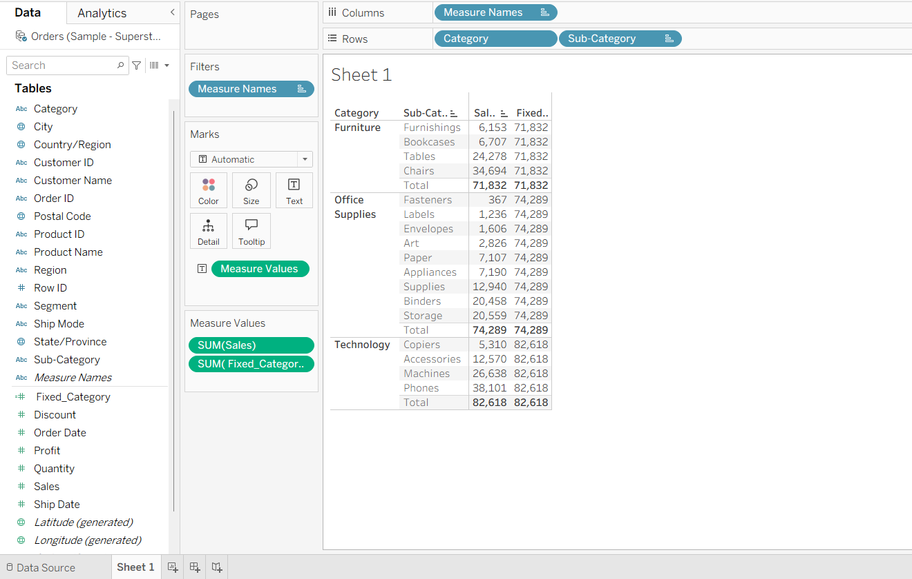

EXCLUDE

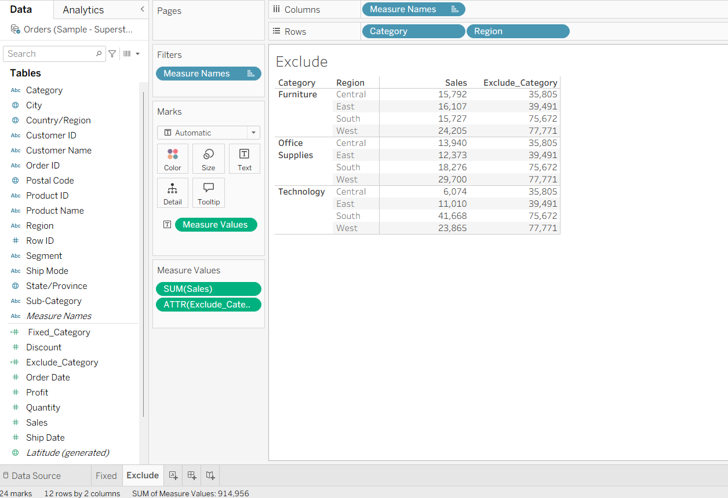

{INCLUDE [Sub-Category]: SUM([Sales])}

